Part 2:

1. Constants – Constant Definition

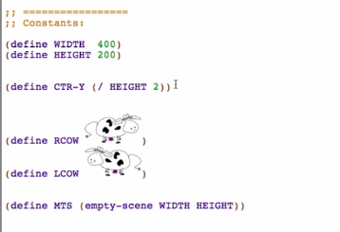

1. Changing – Data Definitions
2. Structure definition



1. Type comment



1. Interpretation

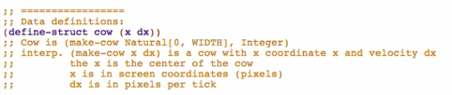

1. Examples

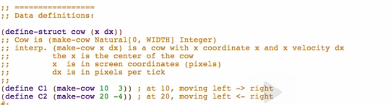

1. Template

